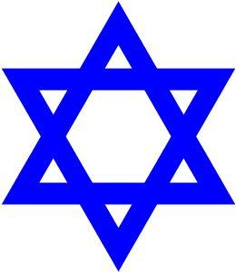
Holocaust Reflections
Journals 3 & 4

Place the letter in the correct spot on the Pyramid of Hate

a. Propaganda
b. Anti-Semitism
c. Final Solution
d. Jewish Ghettos

Explain why each part of the Pyramid of Hate fits in that spot on the pyramid. In other words, please explain each part of the pyramid of Hate.

- Propaganda

- Anti-Semitism

- Final Solution

- Jewish Ghettos

The establishment of ghettos, marked the end of freedom of movement for Jews. Write about what freedom means to you in your life.

What would it mean to you to lose your freedom? Explain your answer.

