Cartoon # 1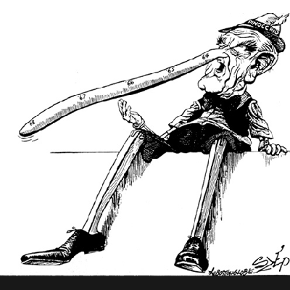
Cartoon # 2
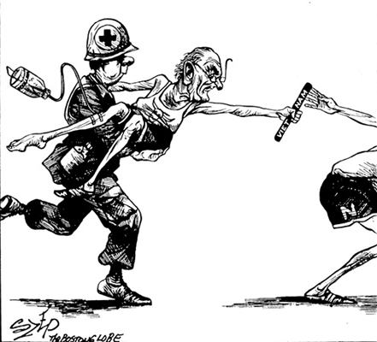
Cartoon # 3
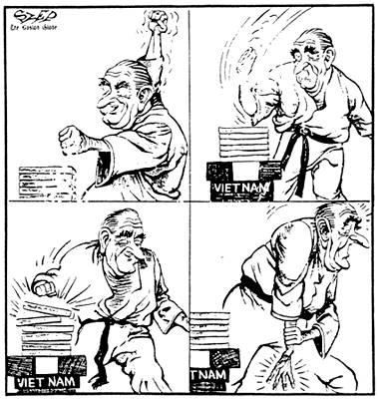
Cartoon # 4
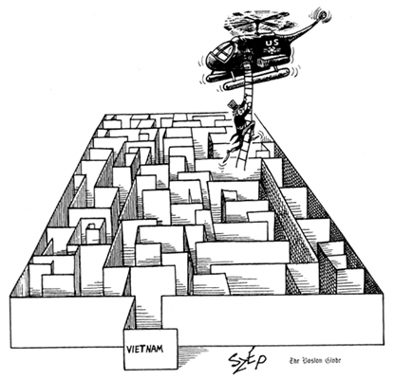
Name: ________________________________
Political Cartoon Activity
Please use the four political cartoons to answer the following questions.

- What is the topic of all four of the cartoons? Explain how you know this.

- Who is the character in the first cartoon and why do you think he is represented that way?

- What is the significance of the numbers on the character’s nose?

- Does the first cartoon have a positive or negative message? Explain how you know this.

- Who are the three people in the second cartoon supposed to represent?

- Why is the one man being carried in the second cartoon?

- What is the significance of the baton in the cartoon?

- Does the second cartoon have a positive or negative message? Explain how you know this.

- Who is the man in the third cartoon and what is he attempting to do?

- How does this cartoon relate to what we have been discussing in class?

- Does the third cartoon have a positive or negative message? Explain how you know this.

- Who is the man in the fourth cartoon supposed to represent and what is he doing?

- What is the maze supposed to represent? Why do you think it is represented that way?

- Does the fourth cartoon have a positive or negative message? Explain how you know this.

- Of the four cartoons, which cartoon do you believe best represents the situation as it pertains the United States? Support your answer.

